**Supplementary materials for Martin et al 2015 - Stand dieback and collapse in a temperate forest and its impact on forest structure and biodiversity**

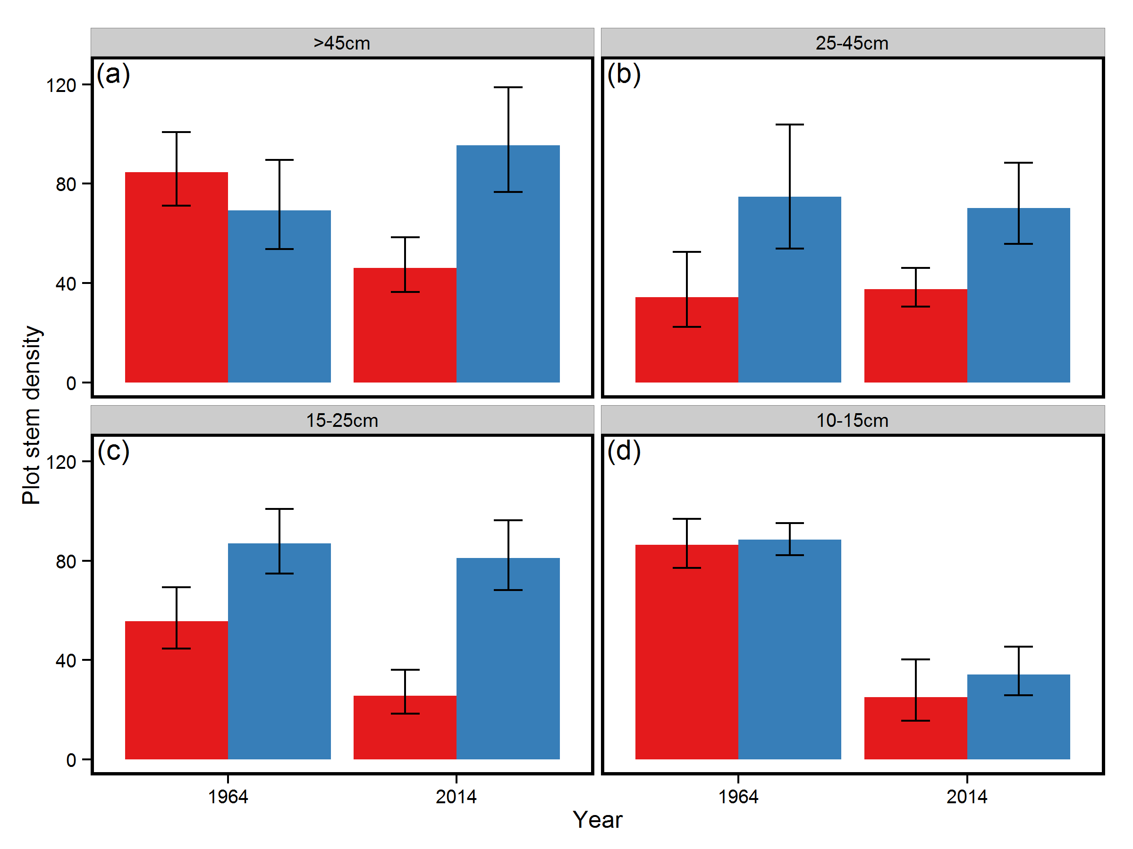

Figure S1 – Differences in stem density for trees (a) >45cm DBH, (b) 25-45cm DBH, (c) 15-25cm DBH and (d) 10-15cm DBH in subplots that collapsed at some point from 1964-2014 (red) and those that remained stable (blue). Data are presented for the years 1964 and 2014. Bars represent model averaged coefficients of generalised mixed models and error bars 95% confidence intervals of these coefficients.

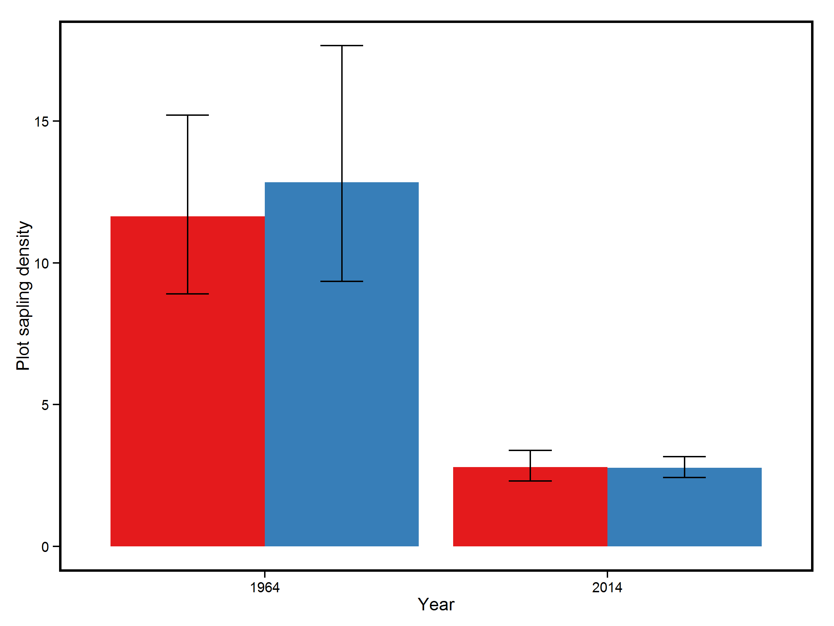

Figure S2 - Differences in stem density for saplings in subplots that collapsed at some point from 1964-2014 (red) and those that remained stable (blue) for the years 1964 and 2014. Bars represent model averaged coefficients of generalised mixed models and error bars 95% confidence intervals of these coefficients.

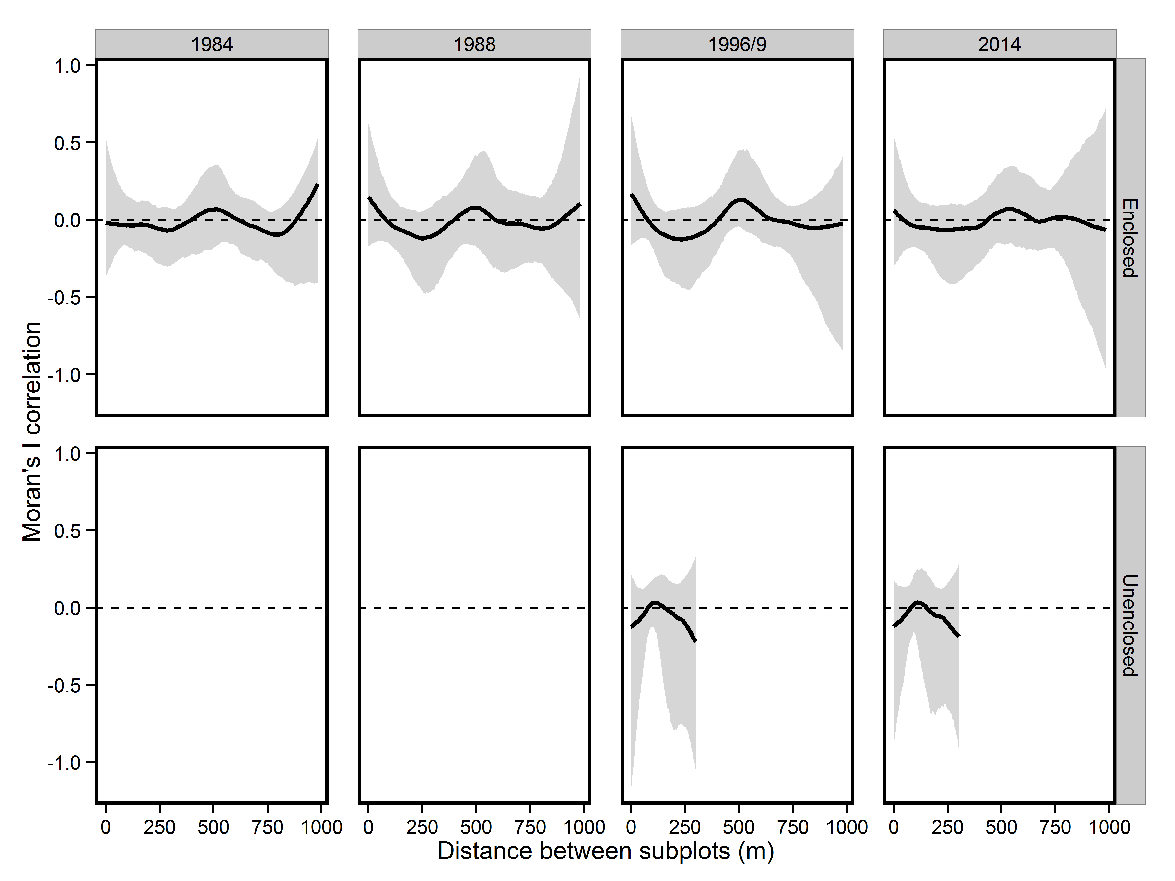

Figure S3 – Relationship between Moran’s I correlation for percentage decline in subplot BA and distance between subplots used in pairwise comparisons for both Enclosed and Unenclosed transects. Solid lines represent median bootstrapped correlations, and the grey shaded area the 95% confidence intervals for these correlations. The dashed line indicates where correlation was equal to zero. At no distance are pairwise correlations deemed to be significantly different from zero (α=0.05) since the grey shaded area overlap zero at all times.

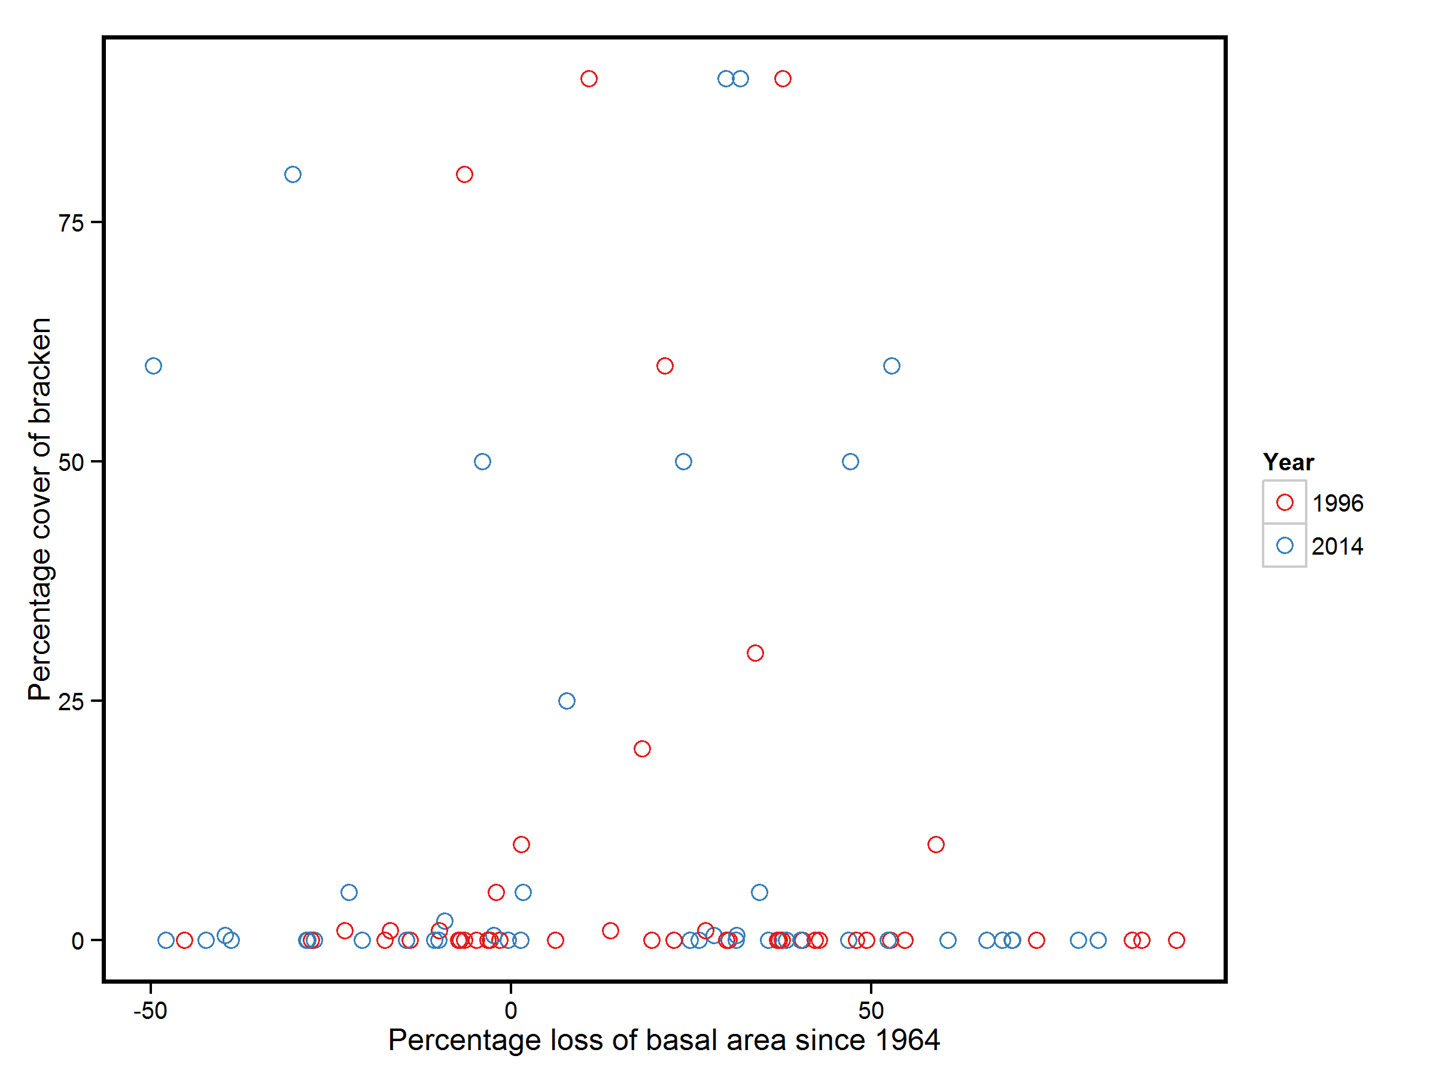

Figure S4 – Lack of relationship between percentage loss of subplot basal area and the percentage cover of bracken

Table S1 - Generalised linear mixed models considered for explanation of changes in subplot stem density and associated measures of parsimony (AICc), support (ΔAICc, AICc weight) and goodness of fit (Marginal R2)

|  |  |  |  |  |  |  |
| --- | --- | --- | --- | --- | --- | --- |
| **Model structure** | Degrees of freedom | Log likelihood | AICc | ΔAICc | AICc weight | Marginal R2 |
| Year*Collapse | 7 | -838.301 | 1691.024 | 0 | 0.98 | 0.37 |
| Year | 5 | -844.697 | 1699.619 | 8.59 | 0.01 | 0.31 |
| Year+Collapse | 6 | -844.502 | 1701.32 | 10.30 | <0.01 | 0.32 |
| Null model | 4 | -888.421 | 1784.992 | 93.97 | <0.01 | 0 |
| Collapse | 5 | -888.334 | 1786.893 | 95.87 | <0.01 | <0.01 |

Table S2 – Coefficient estimates for the most parsimonious model explaining changes in subplot stem density for the period 1964-2014, note that coefficients are in log units due to use of poisson generalised linear mixed models

|  |  |  |  |  |
| --- | --- | --- | --- | --- |
| Model Parameter | Estimate | SE | z.value | P value |
| Intercept | 3.286 | 0.102 | 32.269 | <0.0001 |
| Collapsed | -0.015 | 0.128 | -0.117 | 0.91 |
| Year | -0.017 | 0.003 | -6.573 | <0.001 |
| Collapsed*Year | -0.012 | 0.003 | -3.697 | <0.001 |

Table S3 - Generalised linear mixed models considered for explanation of changes in subplot stem density for trees >45cm DBH and associated measures of parsimony (AICc), support (ΔAICc, AICc weight) and goodness of fit (Marginal R2)

|  |  |  |  |  |  |  |
| --- | --- | --- | --- | --- | --- | --- |
| **Model structure** | **Degrees of freedom** | **Log likelihood** | **AICc** | **ΔAICc** | **AICc weight** | **Marginal R2** |
| Year*Collapse | 5 | -210.001 | 430.519 | 0 | 1 | 0.214 |
| Year+Collapse | 4 | -218.823 | 445.988 | 15.469 | <0.001 | 0.073 |
| Collapse | 3 | -220.788 | 447.780 | 17.261 | <0.001 | 0.040 |
| Year | 3 | -221.053 | 448.310 | 17.791 | <0.001 | 0.037 |
| Null model | 2 | -223.018 | 450.137 | 19.618 | <0.001 | 0 |

Table S4 - Coefficient estimates for the most parsimonious model explaining changes in subplot stem density for trees >45cm DBH for the period 1964-2014, note that coefficients are in log units due to use of poisson generalised linear mixed models

|  |  |  |  |  |
| --- | --- | --- | --- | --- |
| **Model Parameter** | **Estimate** | **SE** | **z.value** | **P value** |
| Intercept | 1.020 | 0.128 | 7.965 | <0.001 |
| Year | 0.320 | 0.168 | 1.902 | 0.057 |
| Collapse | 0.200 | 0.155 | 1.288 | 0.198 |
| Year*Collapse | -0.926 | 0.223 | -4.151 | <0.001 |

Table S5 - Generalised linear mixed models considered for explanation of changes in subplot stem density for trees 25-45cm DBH and associated measures of parsimony (AICc), support (ΔAICc, AICc weight) and goodness of fit (Marginal R2)

|  |  |  |  |  |  |  |
| --- | --- | --- | --- | --- | --- | --- |
| **Model structure** | **Degrees of freedom** | **Log likelihood** | **AICc** | **ΔAICc** | **AICc weight** | **Marginal R2** |
| Collapse | 3 | -222.685 | 451.574 | 0 | 0.558 | 0.144 |
| Collapse+Year | 4 | -222.214 | 452.771 | 1.197 | 0.307 | 0.147 |
| Collapse*Year | 5 | -221.979 | 454.474 | 2.901 | 0.131 | 0.146 |
| Null model | 2 | -229.092 | 462.285 | 10.711 | 0.003 | 0 |
| Year | 3 | -228.621 | 463.446 | 11.872 | 0.001 | 0.003 |

Table S6 - Coefficient estimates for the most parsimonious model explaining changes in subplot stem density for trees 25-45cm DBH for the period 1964-2014, note that coefficients are in log units due to use of poisson generalised linear mixed models

|  |  |  |  |  |
| --- | --- | --- | --- | --- |
| Model Parameter | Estimate | SE | z.value | P value |
| Intercept | 1.095 | 0.167 | 6.477 | <0.0001 |
| Collapse | -0.779 | 0.218 | 3.544 | <0.0001 |
| Year | -0.062 | 0.118 | 0.527 | 0.599 |
| Year*Collapse | 0.022 | 0.105 | 0.208 | 0.835 |

Table S7 - Generalised linear mixed models considered for explanation of changes in subplot stem density for trees 15-25cm DBH and associated measures of parsimony (AICc), support (ΔAICc, AICc weight) and goodness of fit (Marginal R2)

|  |  |  |  |  |  |  |
| --- | --- | --- | --- | --- | --- | --- |
| **Model structure** | **Degrees of freedom** | **Log likelihood** | **AICc** | **ΔAICc** | **AICc weight** | **Marginal R2** |
| Collapse*Year | 5 | -251.932 | 514.381 | 0 | 0.423 | 0.124 |
| Collapse+Year | 4 | -253.216 | 514.774 | 0.393 | 0.348 | 0.109 |
| Collapse | 3 | -254.762 | 515.727 | 1.346 | 0.216 | 0.090 |
| Year | 3 | -258.000 | 522.204 | 7.823 | 0.008 | 0.019 |
| Null model | 2 | -259.545 | 523.191 | 8.810 | 0.005 | 0 |

Table S8 - Coefficient estimates for the most parsimonious model explaining changes in subplot stem density for trees 15-25cm DBH for the period 1964-2014, note that coefficients are in log units due to use of poisson generalised linear mixed models

|  |  |  |  |  |
| --- | --- | --- | --- | --- |
| Model Parameter | Estimate | SE | z.value | P value |
| Intercept | 1.246 | 0.076 | 16.297 | <0.0001 |
| Year | -0.070 | 0.088 | 0.796 | 0.426 |
| Collapse | -0.446 | 0.113 | 3.933 | <0.001 |
| Year*Collapse | -0.136 | 0.172 | 0.790 | 0.429 |

Table S9 - Generalised linear mixed models considered for explanation of changes in subplot stem density for trees 10-15cm DBH and associated measures of parsimony (AICc), support (ΔAICc, AICc weight) and goodness of fit (Marginal R2)

|  |  |  |  |  |  |  |
| --- | --- | --- | --- | --- | --- | --- |
| **Model structure** | **Degrees of freedom** | **Log likelihood** | **AICc** | **ΔAICc** | **AICc weight** | **Marginal R2** |
| Year | 3 | -243.417 | 493.038 | 0 | 0.422 | 0.280 |
| Year*Collapse | 5 | -241.292 | 493.100 | 0.063 | 0.409 | 0.307 |
| Year+Collapse | 4 | -243.261 | 494.863 | 1.825 | 0.169 | 0.283 |
| Null model | 2 | -283.497 | 571.094 | 78.058 | <0.001 | 0 |
| Collapse | 3 | -283.34 | 572.884 | 79.846 | <0.001 | 0.006 |

Table S10 - Coefficient estimates for the most parsimonious model explaining changes in subplot stem density for trees 10-15cm DBH for the period 1964-2014, note that coefficients are in log units due to use of poisson generalised linear mixed models

|  |  |  |  |  |
| --- | --- | --- | --- | --- |
| Model Parameter | Estimate | SE | z.value | P value |
| Intercept | 1.252 | 0.030 | 0.030 | <0.0001 |
| Year | -0.931 | 0.148 | 0.148 | <0.001 |
| Collapse | -0.005 | 0.047 | 0.047 | 0.920 |
| Year*Collapse | -0.208 | 0.250 | 0.250 | 0.400 |

Table S11 – Generalised linear mixed models considered for explanation of differences in the subplot abundance of beech saplings and associated measures of parsimony (AICc), support (ΔAICc, AICc weight) and goodness of fit (Marginal R2)

|  |  |  |  |  |  |  |
| --- | --- | --- | --- | --- | --- | --- |
| **Model structure** | **Degrees of freedom** | **Log likelihood** | **AICc** | **ΔAICc** | **AICc weight** | **Marginal R2** |
| Collapse + Year | 4 | -149.444 | 307.309 | 0 | 0.403 | 0.310 |
| Collapse*Year | 5 | -148.553 | 307.744 | 0.436 | 0.324 | 0.314 |
| Year | 3 | -150.918 | 308.086 | 0.777 | 0.273 | 0.302 |
| Collapse | 3 | -215.043 | 436.336 | 129.027 | <0.001 | <0.001 |
| Null model | 2 | -216.474 | 437.071 | 129.763 | <0.001 | 0.000 |

Table S12 - Coefficient estimates from model averaging of generalised linear mixed models considered for explanation of differences in sapling density

|  |  |  |  |  |
| --- | --- | --- | --- | --- |
| **Model parameter** | **Estimate** | **SE** | **Z value** | **P value** |
| Intercept | 2.454 | 0.137 | 17.786 | <0.001 |
| Collapse | -1.426 | 0.98 | 14.380 | <0.001 |
| Year | 0.099 | 0.162 | 0.605 | 0.545 |
| Collapse*Year | -0.008 | 0.068 | 0.116 | 0.907 |

Table S13 - Generalised linear mixed models considered for explanation of changes in subplot tree species richness and associated measures of parsimony (AICc), support (ΔAICc, AICc weight) and goodness of fit (Marginal R2)

|  |  |  |  |  |  |  |
| --- | --- | --- | --- | --- | --- | --- |
| **Model structure** | **Degrees of freedom** | **Log likelihood** | **AICc** | **ΔAICc** | **AICc weight** | **Marginal R2** |
| BA | 3 | -326.643 | 659.401 | 0 | 0.480 | 0.031 |
| BA+BA2 | 4 | -325.635 | 659.463 | 0.061 | 0.465 | 0.048 |
| Null model | 2 | -329.838 | 663.734 | 4.333 | 0.055 | 0 |

Table S14 - Coefficient estimates for the most parsimonious model explaining changes in subplot subplot tree species richness, note that coefficients are in log units due to use of poisson generalised linear mixed models

|  |  |  |  |  |
| --- | --- | --- | --- | --- |
| Model Parameter | Estimate | SE | z.value | P value |
| Intercept | 1.039 | 0.049 | 0.049 | <0.0001 |
| BA loss since 1964 | -0.284 | 0.108 | 0.109 | 0.009 |
| BA loss since 19642 | -0.083 | 0.104 | 0.105 | 0.428 |

Table S15 - Linear mixed models considered for explanation of changes in subplot tree community composition using the Tanner index and associated measures of parsimony (AICc), support (ΔAICc, AICc weight) and goodness of fit (Marginal R2)

|  |  |  |  |  |  |  |
| --- | --- | --- | --- | --- | --- | --- |
| **Model structure** | **Degrees of freedom** | **Log likelihood** | **AICc** | **ΔAICc** | **AICc weight** | **Marginal R2** |
| BA loss+BA loss2 | 8 | -108.801 | 234.311 | 0 | 1 | 0.47 |
| BA loss | 7 | -130.077 | 274.702 | 40.39 | <0.01 | 0.40 |
| Null model | 6 | -135.940 | 284.290 | 50.00 | <0.01 | 0 |

Table S16 - Coefficient estimates for the most parsimonious linear mixed model explaining changes in subplot tree community composition using the Tanner index

|  |  |  |  |  |
| --- | --- | --- | --- | --- |
| Model Parameter | Estimate | SE | z.value | P value |
| Intercept | 1.255 | 0.201 | 6.245 | <0.001 |
| BA loss | 1.453 | 0.137 | 10.633 | <0.001 |
| BA loss2 | -0.763 | 0.101 | -7.539 | <0.001 |

Table S17 - Linear mixed models considered for explanation of changes in subplot grass cover and associated measures of parsimony (AICc), support (ΔAICc, AICc weight) and goodness of fit (Marginal R2)

|  |  |  |  |  |  |  |
| --- | --- | --- | --- | --- | --- | --- |
| **Model structure** | **Degrees of freedom** | **Log likelihood** | **AICc** | **ΔAICc** | **AICc weight** | **Marginal R2** |
| Year*Collapse | 8 | -284.812 | 586.757 | 0 | 0.99 | 0.44 |
| Year+Collapse | 6 | -291.873 | 596.398 | 9.641 | <0.01 | 0.40 |
| Year | 5 | -295.229 | 600.919 | 14.161 | <0.01 | 0.36 |
| Collapse | 4 | -327.115 | 662.535 | 75.778 | <0.01 | 0.05 |
| Null model | 3 | -330.798 | 667.779 | 81.021 | <0.01 | 0 |

Table S18 - Coefficient estimates for the most parsimonious linear mixed model explaining changes in subplot grass cover

|  |  |  |  |  |  |
| --- | --- | --- | --- | --- | --- |
| **Model parameter** | **Estimate** | **SE** | **df** | **T value** | **P value** |
| Intercept | -5.324 | 0.455 | 112.427 | -11.699 | <0.001 |
| 1996 | 2.426 | 0.555 | 87.501 | 4.371 | <0.001 |
| 2014 | 2.106 | 0.555 | 87.501 | 3.794 | <0.001 |
| Collapse | -0.289 | 0.617 | 112.427 | -0.467 | 0.640 |
| 1996*Collapse | 1.967 | 0.748 | 86.787 | 2.631 | 0.009 |
| 2014*Collapse | 2.495 | 0.748 | 86.787 | 3.338 | <0.001 |

Table S17 - Linear mixed models considered for explanation of differences in subplot grass cover over the gradient of collapse and associated measures of parsimony (AICc), support (ΔAICc, AICc weight) and goodness of fit (Marginal R2)

|  |  |  |  |  |  |  |
| --- | --- | --- | --- | --- | --- | --- |
| **Model structure** | **Degrees of freedom** | **Log likelihood** | **AICc** | **ΔAICc** | **AICc weight** | **Marginal R2** |
| BA+BA2+BA3 | 8 | -169.230 | 356.2 | 0 | 0.721 | 0.385 |
| BA+BA2 | 7 | -171.398 | 358.2 | 1.9 | 0.276 | 0.380 |
| BA | 6 | -176.957 | 366.9 | 10.7 | 0.003 | 0.327 |
| Null model | 5 | -181.262 | 373.2 | 17.0 | <0.001 | 0 |

Table S18 - Coefficient estimates from model averaging of linear mixed models considered for explanation of differences in subplot grass cover over the gradient of collapse

|  |  |  |  |  |
| --- | --- | --- | --- | --- |
| **Model parameter** | **Estimate** | **SE** | **Z value** | **P value** |
| Intercept | -2.6180 | 0.2633 | 9.799 | <0.001 |
| Loss in BA since 1964 | 1.8238 | 0.8158 | 2.203 | 0.0276 |
| Loss in BA since 19642 | 3.4729 | 2.2121 | 1.547 | 0.122 |
| Loss in BA since 19643 | 0.7975 | 2.546 | 0.276 | 0.783 |

Table S19 - Linear mixed models considered for explanation of differences in subplot bracken cover over the gradient of collapse and associated measures of parsimony (AICc), support (ΔAICc, AICc weight) and goodness of fit (Marginal R2)

|  |  |  |  |  |  |  |
| --- | --- | --- | --- | --- | --- | --- |
| **Model structure** | **Degrees of freedom** | **Log likelihood** | **AICc** | **ΔAICc** | **AICc weight** | **Marginal R2** |
| Null model | 3 | 27.973 | -49.668 | 0 | 0.842 | 0 |
| BA | 4 | 26.937 | -45.403 | 4.264 | 0.100 | 0.014 |
| BA+BA2+BA3 | 6 | 28.301 | -43.591 | 6.077 | 0.040 | 0.031 |
| BA+BA2 | 5 | 26.327 | -41.941 | 7.727 | 0.018 | 0.019 |

Table S20 - Coefficient estimates from model averaging of linear mixed models considered for explanation of differences in subplot bracken cover over the gradient of collapse

|  |  |  |  |  |
| --- | --- | --- | --- | --- |
| **Model parameter** | **Estimate** | **SE** | **Z value** | **P value** |
| Intercept | 0.107 | 0.043 | 2.470 | 0.014 |
| BA | 0.033 | 0.101 | 0.320 | 0.749 |
| BA2 | 0.295 | 0.253 | 1.156 | 0.247 |
| BA3 | 0.430 | 0.373 | 1.146 | 0.252 |

Table S21 – Generalised linear mixed models considered for explanation of differences in subplot ground flora species richness over the gradient of collapse and associated measures of parsimony (AICc), support (ΔAICc, AICc weight) and goodness of fit (Marginal R2)

|  |  |  |  |  |  |  |
| --- | --- | --- | --- | --- | --- | --- |
| **Model structure** | **Degrees of freedom** | **Log likelihood** | **AICc** | **ΔAICc** | **AICc weight** | **Marginal R2** |
| BA+BA2 | 4 | -222.095 | 452.677 | 0 | 0.682 | 0.136 |
| BA+BA2+BA3 | 5 | -222.063 | 454.867 | 2.190 | 0.228 | 0.135 |
| BA | 3 | -225.593 | 457.476 | 4.798 | 0.062 | 0.057 |
| Null model | 2 | -227.447 | 459.037 | 6.360 | 0.028 | 0 |

Table S22 - Coefficient estimates from model averaging of generalised linear mixed models considered for explanation of differences in subplot ground flora species richness over the gradient of collapse

|  |  |  |  |  |
| --- | --- | --- | --- | --- |
| **Model parameter** | **Estimate** | **SE** | **Z value** | **P value** |
| Intercept | 1.903 | 0.079 | 23.693 | <0.001 |
| Loss in BA since 1964 | -0.027 | 0.239 | 0.241 | 0.912 |
| Loss in BA since 19642 | 1.03402 | 0.369 | 2.762 | 0.006 |

Table S23 - Linear mixed models considered for explanation of differences in community weighted Ellenburg light indicator values for subplot ground flora over the gradient of collapse and associated measures of parsimony (AICc), support (ΔAICc, AICc weight) and goodness of fit (Marginal R2)

|  |  |  |  |  |  |  |
| --- | --- | --- | --- | --- | --- | --- |
| **Model structure** | **Degrees of freedom** | **Log likelihood** | **AICc** | **ΔAICc** | **AICc weight** | **Marginal R2** |
| BA | 4 | -35.818 | 80.124 | 0 | 0.593 | 0.100 |
| BA+BA2 | 5 | -35.932 | 82.606 | 2.482 | 0.171 | 0.101 |
| Null model | 3 | -38.383 | 83.054 | 2.931 | 0.137 | 0 |
| BA+BA2+ BA3 | 6 | -35.332 | 83.715 | 3.591 | 0.098 | 0.102 |

Table S24 - Coefficient estimates from model averaging of linear mixed models considered for explanation of differences in community weighted Ellenburg light indicator values for subplot ground flora over the gradient of collapse

|  |  |  |  |  |
| --- | --- | --- | --- | --- |
| **Model parameter** | **Estimate** | **SE** | **Z value** | **P value** |
| Intercept | -6.432 | 0.066 | 96.433 | <0.001 |
| Loss in BA since 1964 | 0.409 | 0.185 | 2.173 | 0.030 |
| Loss in BA since 19642 | -0.090 | 0.358 | 0.247 | 0.805 |
| Loss in BA since 19643 | -0.011 | 0.420 | 0.026 | 0.979 |

Table S23 – Linear mixed models considered for explanation of differences in community weighted Ellenburg nitrogen indicator values for subplot ground flora over the gradient of collapse and associated measures of parsimony (AICc), support (ΔAICc, AICc weight) and goodness of fit (Marginal R2)

|  |  |  |  |  |  |  |
| --- | --- | --- | --- | --- | --- | --- |
| **Model structure** | **Degrees of freedom** | **Log likelihood** | **AICc** | **ΔAICc** | **AICc weight** | **Marginal R2** |
| Null model | 3 | -106.385 | 219.049 | 0 | 0.508 | 0 |
| BA+BA2+ BA3 | 6 | -103.940 | 220.891 | 1.842 | 0.202 | 0.022 |
| BA+BA2 | 5 | -105.351 | 221.416 | 2.367 | 0.155 | 0.021 |
| BA | 4 | -106.614 | 221.699 | 2.650 | 0.135 | 0.019 |

Table S24 – Linear mixed models considered for explanation of differences in community weighted Ellenburg moisture indicator values for subplot ground flora over the gradient of collapse and associated measures of parsimony (AICc), support (ΔAICc, AICc weight) and goodness of fit (Marginal R2)

|  |  |  |  |  |  |  |
| --- | --- | --- | --- | --- | --- | --- |
| **Model structure** | **Degrees of freedom** | **Log likelihood** | **AICc** | **ΔAICc** | **AICc weight** | **Marginal R2** |
| BA+BA2+ BA3 | 6 | -131.325 | 275.6629 | 0 | 0.413554 | 0.032 |
| BA | 4 | -134.269 | 277.0088 | 1.345966 | 0.210989 | 0.036 |
| BA+BA2 | 5 | -133.187 | 277.0884 | 1.425565 | 0.202757 | 0 |
| Null model | 3 | -135.565 | 277.4093 | 1.746458 | 0.172701 | 0.038 |

Table S25 – Linear mixed models considered for explanation of differences in the proportion of subplot basal area represented by oak trees >10cm DBH and associated measures of parsimony (AICc), support (ΔAICc, AICc weight) and goodness of fit (Marginal R2)

|  |  |  |  |  |  |  |
| --- | --- | --- | --- | --- | --- | --- |
| **Model structure** | **Degrees of freedom** | **Log likelihood** | **AICc** | **ΔAICc** | **AICc weight** | **Marginal R2** |
| Collapse | 4 | -250.115 | 508.574 | 0 | 0.458 | 0.047 |
| Collapse + Year | 5 | -249.986 | 510.493 | 1.919 | 0.176 | 0.051 |
| Null model | 3 | -252.21 | 510.626 | 2.052 | 0.164 | 0 |
| Collapse*Year | 6 | -249.114 | 510.965 | 2.391 | 0.139 | 0.055 |
| Year | 4 | -252.092 | 512.528 | 3.954 | 0.063 | 0.004 |

Table S26 - Coefficient estimates from model averaging of linear mixed models considered for explanation of differences the proportion of subplot basal area represented by oak trees >10cm DBH

|  |  |  |  |  |
| --- | --- | --- | --- | --- |
| **Model parameter** | **Estimate** | **SE** | **Z value** | **P value** |
| Intercept | -0.338 | 0.425 | 0.789 | 0.430 |
| Collapse | -0.720 | 0.606 | 1.180 | 0.238 |
| Year | -0.053 | 0.235 | 0.222 | 0.824 |
| Collapse*Year | -0.079 | 0.277 | 0.285 | 0.776 |